User Guide

Purpose of this document is to provide the steps to build the current weather web application.

# PREREQUISITES:

* Apache maven tool (version 3.3 or above)
* Java 7 or above
* Internet connection as it uses Yahoo services to get the weather.
* Java home and Maven home should be set in PATH environment variable.

# STEPS:

## Download project from GitHib

URL to download the project is https://github.com/bhoomikatg/Current-weather

Build the project

Open command prompt and go to the path where project is saved. Run command “mvn clean install”.

## Deployment

1. After above command is completed successfully, a target folder should be created under same directory. Go to target folder, there should be a war named as **current-weather-webapp-0.0.1-SNAPSHOT**
2. Deploy the war on any web application server e.g JBoss
3. Restart the server

OR

Use command **mvn tomcat7:run** , which will automatically deploy the war on tomcat

# Using App

After deployment is success.

Open any web browser and type <http://localhost:8080/current-weather>. It should open up the web page as below:

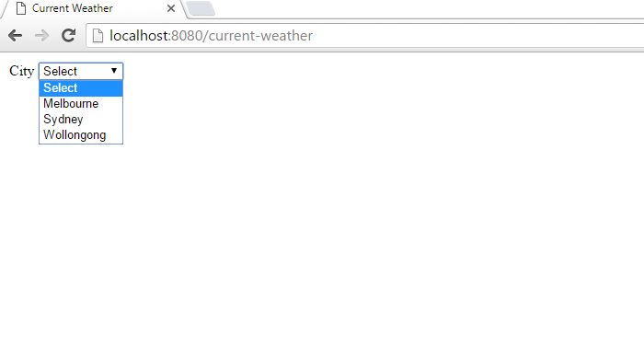

Select the city, it would display the current weather for the selected city.

